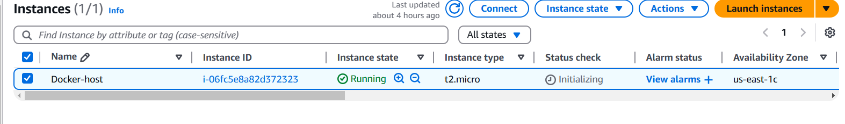

Volume –

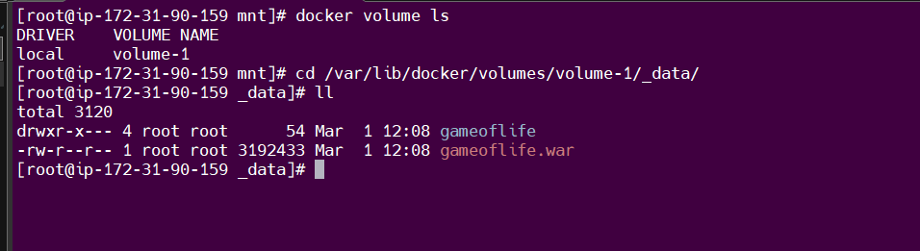

Custome network –

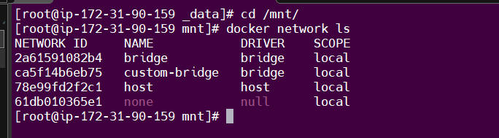

Docker file –

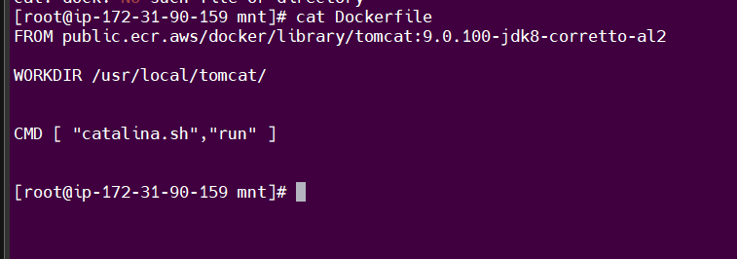

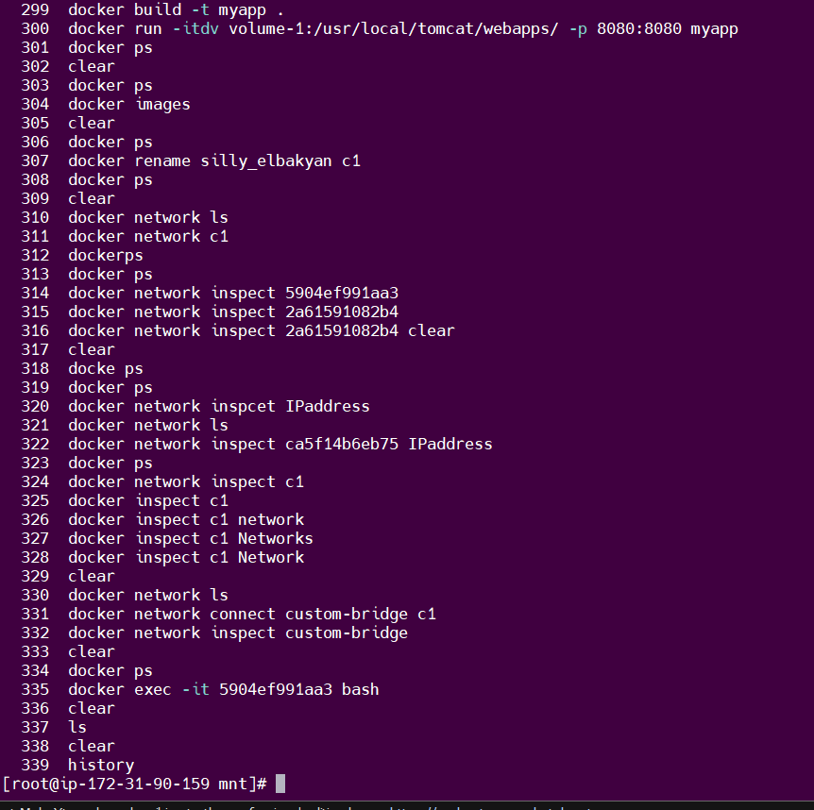

Output –

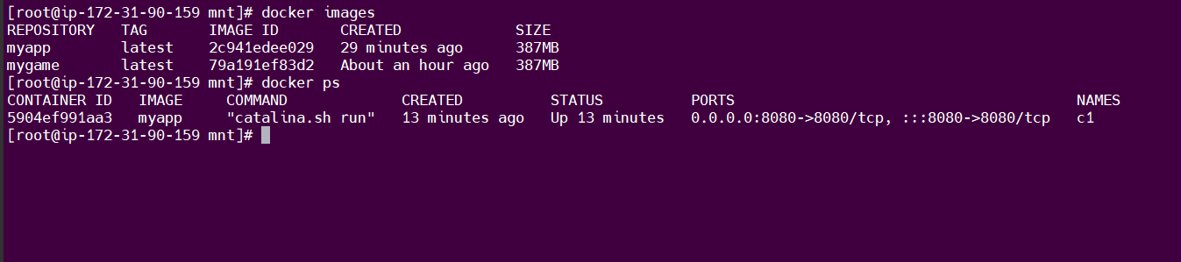

Custom-bridge network added to container 1 -

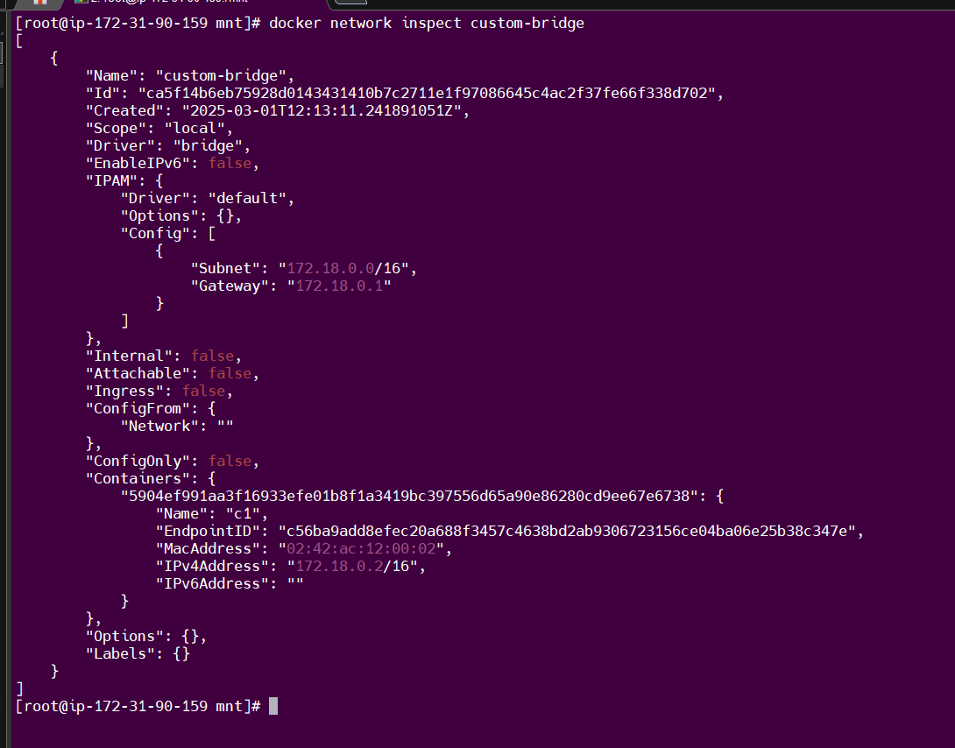

Output –

# docker run -itdv volume-1:/usr/local/tomcat/webapps/ -p 8080:8080 myapp

